**AND functions :**

Check if the pokemon type is fire and has speed greater than 70:

The function returns “True” or “Flase”

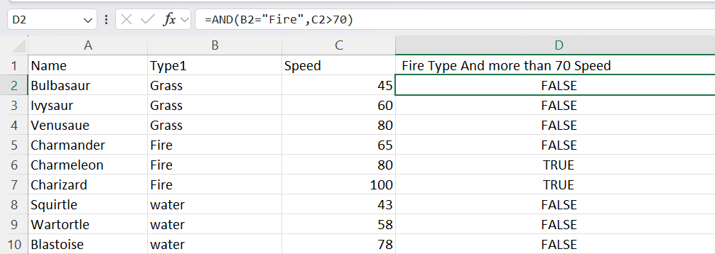

**AND Function (with IF) :**

Combining the AND function with an IF function lets you check multiple conditions for the IF functions :

NOTE : the IF function lets you specify the return value.

Here, the IF function returns “YES” or “NO”.

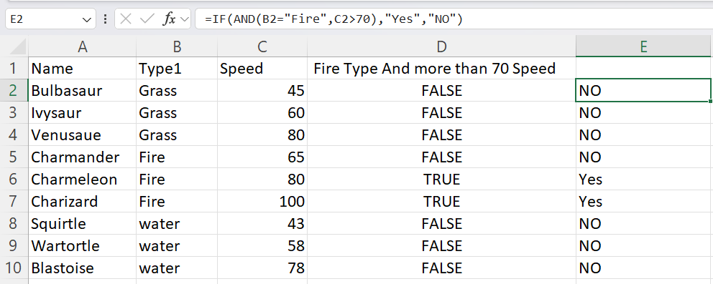

**Average IF Function :**

Find the average speed of Grass type pokemon:

The condition is that the type is “Grass”.

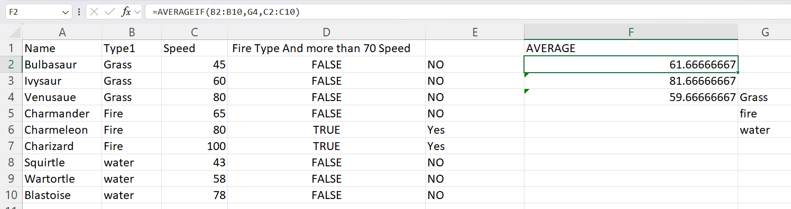

**Average IFS function**

Find the average defense of grass type 1st Generation pokemon:

The condition are that the type is “Grass” and Generation is 1.

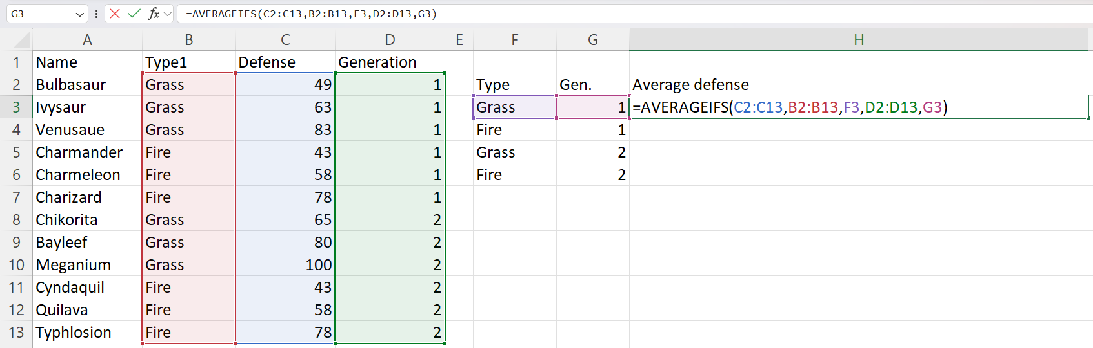

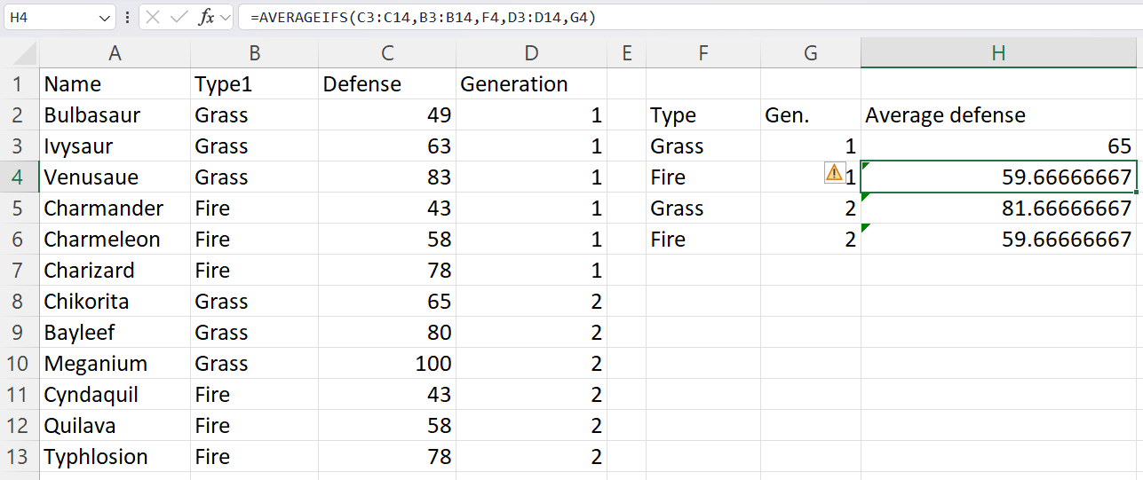

**Concat Function :**

To combine values from multiple Excel cells

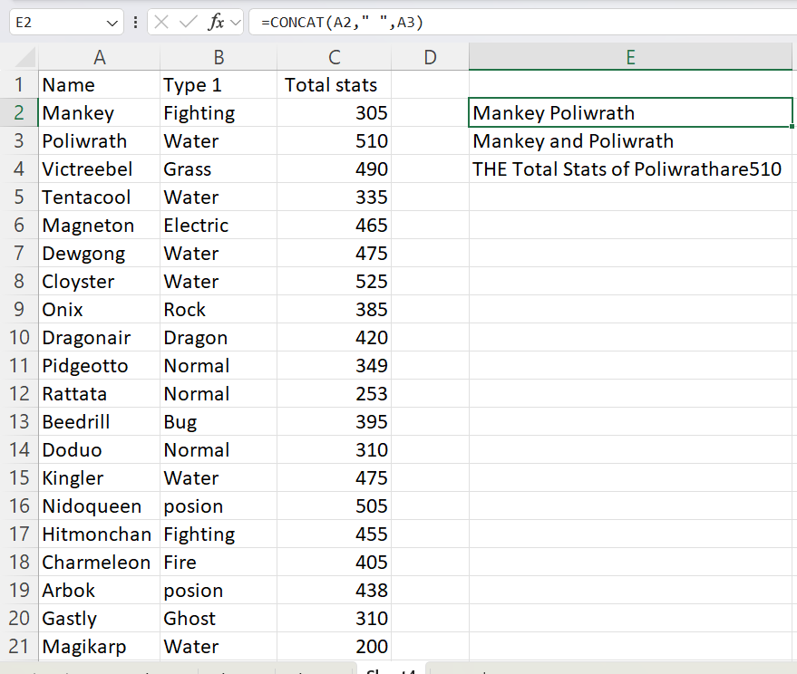

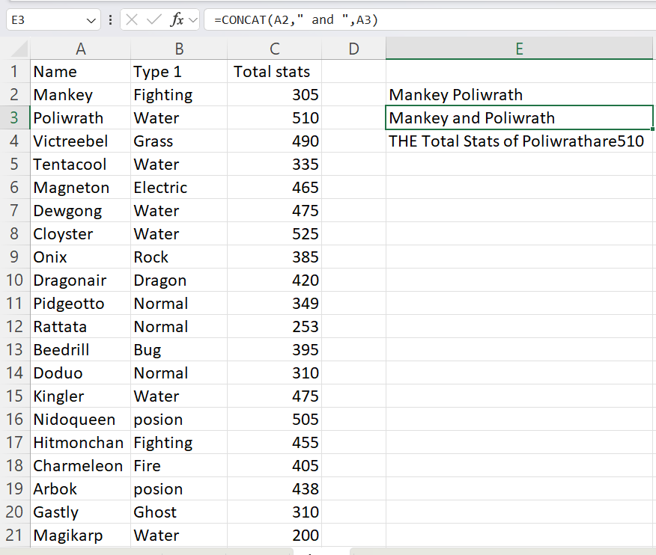

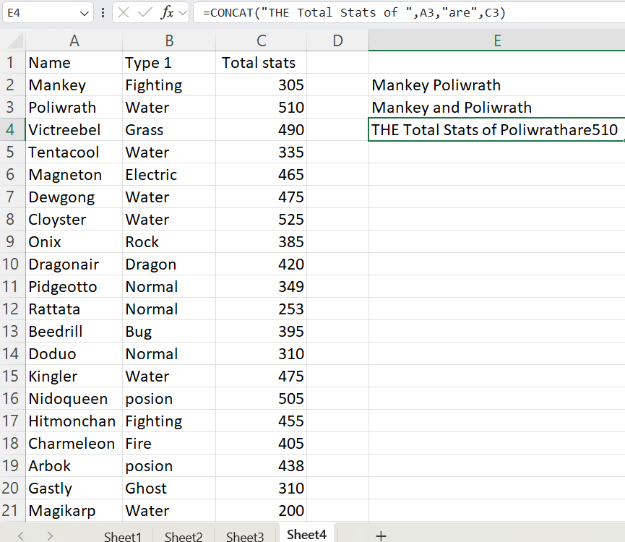

Excel Formulas

1. SUBTOTAL

Moving ahead, let’s now understand how the subtotal function works. The SUBTOTAL() function returns the subtotal in a database. Depending on what you want, you can select either average, count, sum, min, max, min, and others. Let’s have a look at two such examples.

SUBTOTAL =SUBTOTAL(1, A2: A4)

In the subtotal list “1” refers to average. Hence, the above function will give the average of A2: A4 and the answer to it is 11, which is stored in C5. Similarly

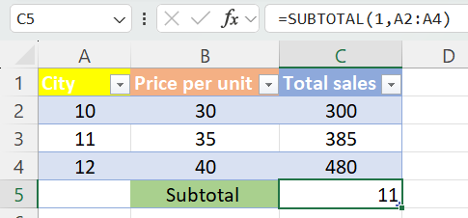

“=SUBTOTAL(4, A2: A4)”

This selects the cell with the maximum value from A2 to A4, which is 12. Incorporating “4” in the function provides the maximum result.

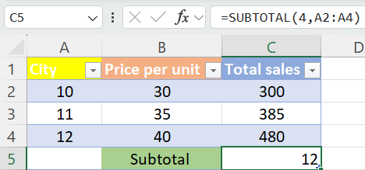

2) Modulus

The MOD() function works on returning the remainder when a particular number is divided by a divisor. Let’s now have a look at the examples below for better understanding.

* The result is stored in B2. We can also directly type “=MOD(10,3)” as it will give the same answer.

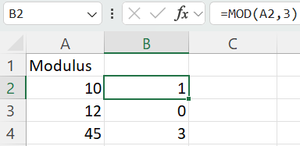

* Similarly, here, we have divided 12 by 4. The remainder is 0 is, which is stored in B3.

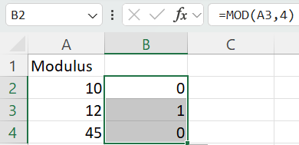

3) POWER

The function “Power()” returns the result of a number raised to a certain power. Let’s have a look at the examples shown below:

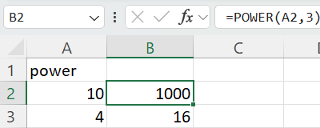

4) ceiling

Next, we have the ceiling function. The CEILING() function rounds a number up to its nearest multiple of significance.

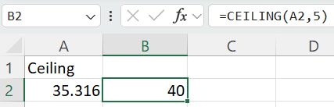

5) Floor

Contrary to the Ceiling function, the floor function rounds a number down to the nearest multiple of significance.

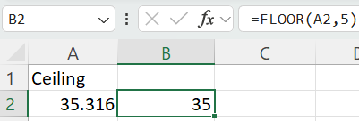

6] LEN

The function LEN() returns the total number of characters in a string. So, it will count the overall characters, including spaces and special characters. Given below is an example of the Len function.

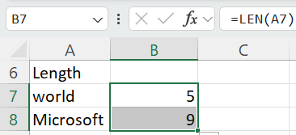

7) Replace

As the name suggests, the REPLACE() function works on replacing the part of a text string with a different text string.

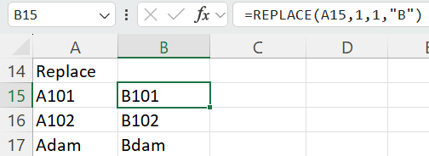

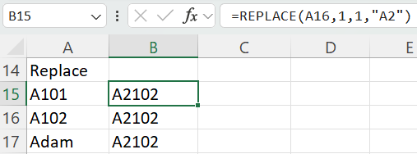

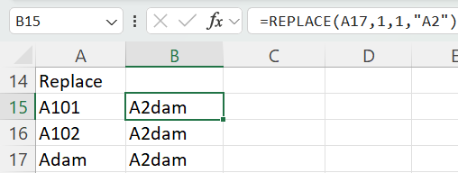

8) Substitute

The SUBSTITUTE() function replaces the existing text with a new text in a text string. The syntax is “=SUBSTITUTE(text, old_text, new_text, [instance_num])”.Here, [instance_num] refers to the index position of the present texts more than once. Given below are a few examples of this function:

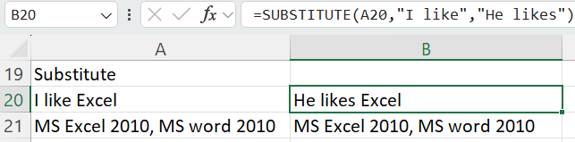

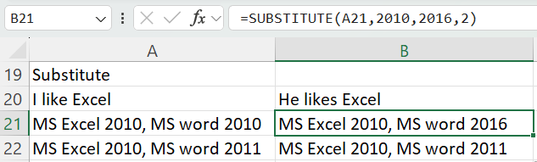

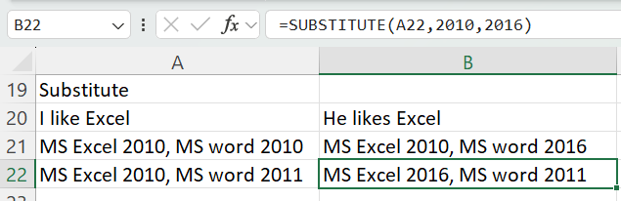

9) Left , Right, Mid

The LEFT() function gives the number of characters from the start of a text string. Meanwhile, the MID() function returns the characters from the middle of a text string, given a starting position and length. Finally, the right() function returns the number of characters from the end of a text string.

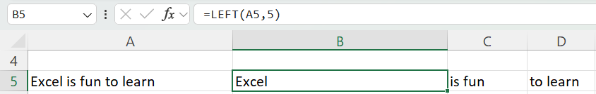

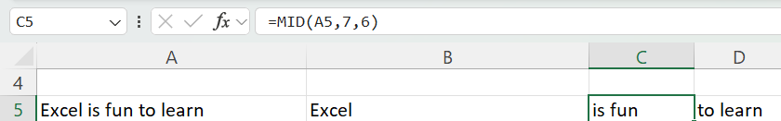

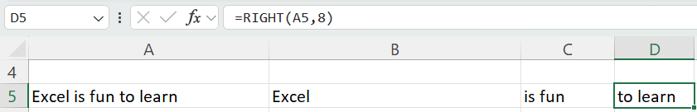

10) Upper, Lower, Proper

The UPPER() function converts any text string to uppercase. In contrast, the LOWER() function converts any text string to lowercase. The PROPER() function converts any text string to proper case, i.e., the first letter in each word will be in uppercase, and all the other will be in lowercase.

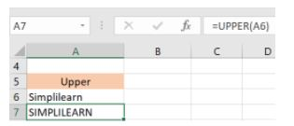

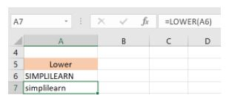

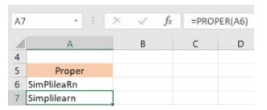

11) NOW(): The NOW() function in Excel gives the current system date and time.

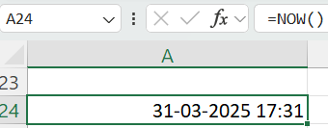

12) Today() : The TODAY() function in Excel provides the current system date.

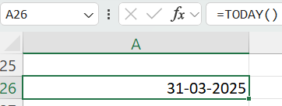

Day function

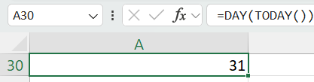

Month function

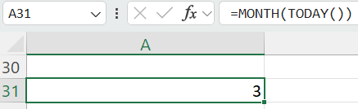

Year

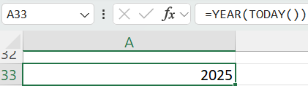

13) Time()

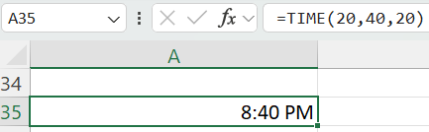

14) Hour, Minute, Second

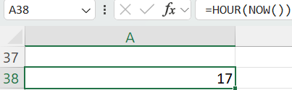

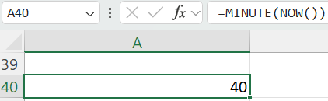

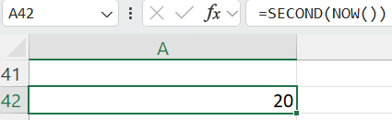

15) DATEDIF : The DATEDIF() function provides the difference between two dates in terms of years, months, or days.

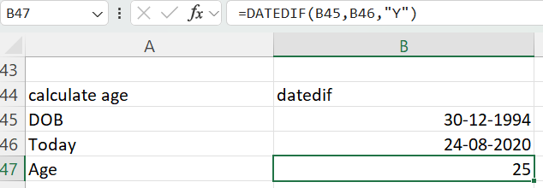

16) Vlookup

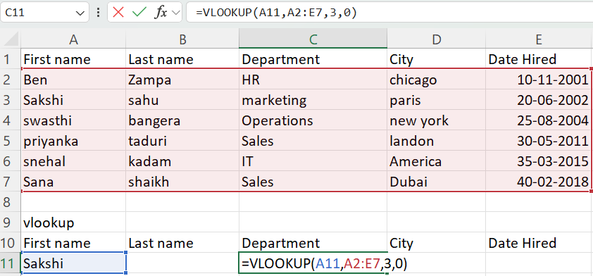

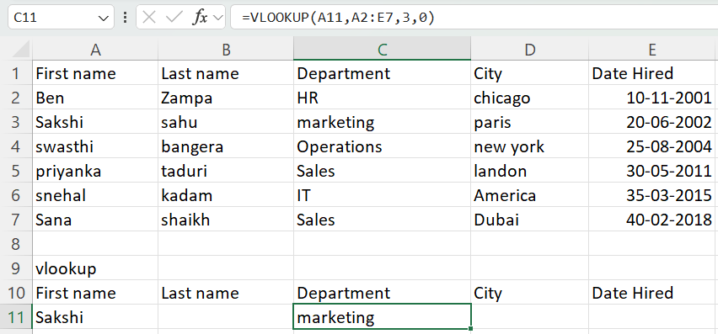

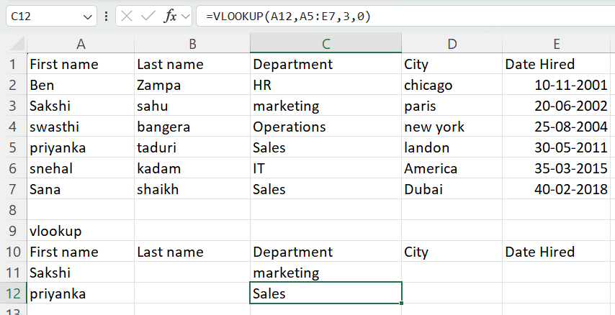

17) HLOOKUP

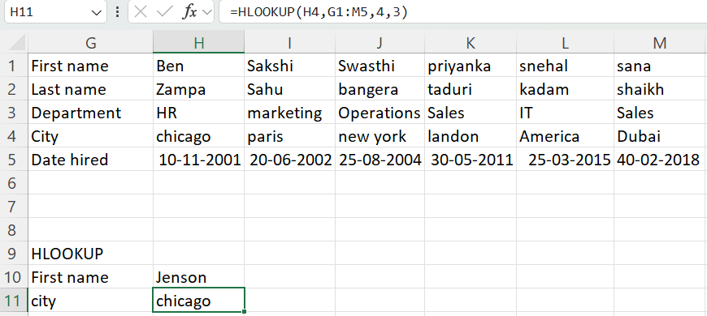

**DROP – DOWN LIST IN EXCEL**

**1) Create the Drop-Down List**

1. Select **cell C1** (or any other cell where you want the drop-down).
2. Go to **Data** → **Data Validation**.
3. Under **Allow**, choose **List**.
4. In the **Source** box, enter:

=A1:A5

1. Click **OK**.

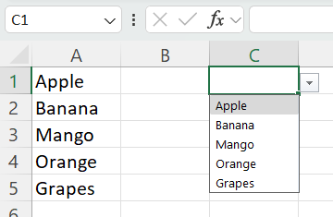

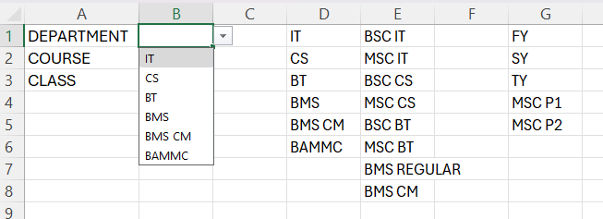

**Transpose a given Data**

Start by highlighting the column that you want to transpose into rows.

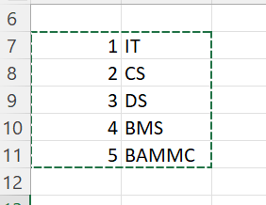

Right-click it, and then select “Copy.”

Next, select the cells on your spreadsheet where you want your first row or column to begin. Right-click on the cell, and then select “Paste Special.”

A module will appear — at the bottom, you'll see an option to transpose.

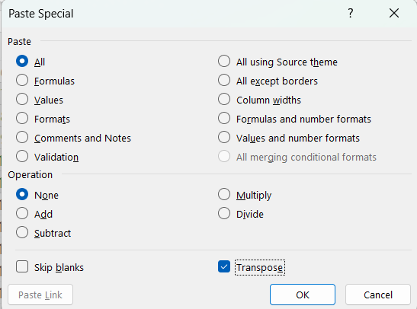

Check that box and select OK.

Your column will now be transferred to a row or vice-versa.

**Input values starting with 0**

Though 0 before any number won’t make any sense, yet sometimes it required to add 0 before some given numbers. FOR EXAMPLE, ACCOUNT NUMBER IN A BANK.

But Excel won’t facilitate us with this “Adding a Zero before number” thing.

So here is a hack to do this.

Add a “single quote(‘)” before your zeros to enter them in a cell.

Type **‘0009 to insert 0009** in your workbook**.**

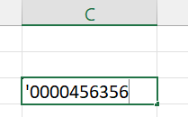

Then press enter



**Pivot Table :**

**Pivot Table**

1)How much in $ did you sell in each city?

Answer:

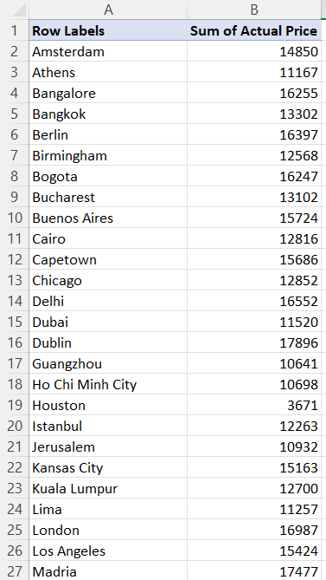 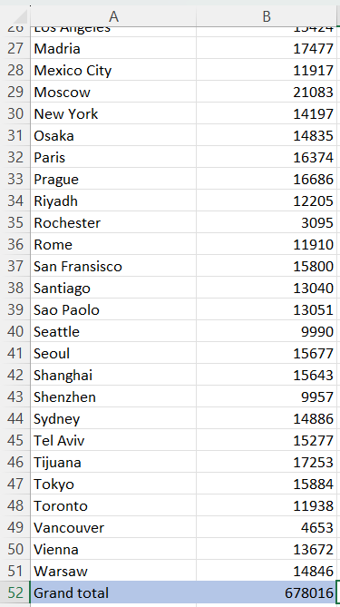

|  |  |  |  |  |  |  |  |  |  |  |  |  |  |  |
| --- | --- | --- | --- | --- | --- | --- | --- | --- | --- | --- | --- | --- | --- | --- |
| Pivot Table is a great tool for summarizing and analyzing data. | | | | | |  |  |  |  |  |  |  |  |  |
| We can use it to perform calculations on our data based on certain criteria. For example - Sales per Store,  Sales per Year, Average Discount per Region, and many more… | | | | | | | | | | | | | | |
|  | |  | |  |  |  |  |  |  |  |  |  |  |  |
| To create a new Pivot Table, we need to click on one of the desired cells in our data range, then click Insert tab,  then Pivot Table    After we click this, the following dialog box will open:    After our Pivot Table is in place, the empty report will look like this:    Take a look at the right corner - This is where we build our Pivot Table.  On the upper side, we can see different field names - These are based on the headers of our original data range.  Now, we can start calculating and slicing our data based on these fields - by dragging the fields to one of the  following areas in the bottom-right corner:  Now, let's see how this works:  We were asked calculate the sum of sells in each city. Our city field is called "Store",and our actual sales are presented in "Actual Price" field.  So basically, what we need to do is to drag the "Store" Field to the rows area (just click and drag), and drag the  "Actual Price" field to the Values area.      Then click value field setting | | | | | | | | | | |  |  |  |  |
|  |  | |
|  |  | |
|  |  | |

2) Per each home appliance item, how many items were sold by your company?

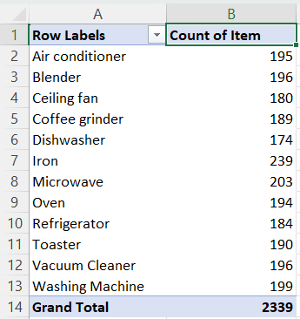 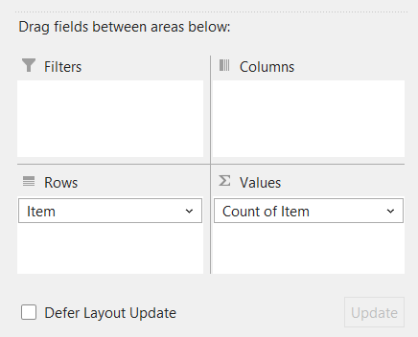

As we can see, when we drag "Item" field to Values, it automaticaly changed to "Count of Item". Excel automatically detected that based on the data we have chosen, we would want to count our items.

3) Now, create a table which shows a breakdown of Total Revenue from each of Items Sold (in Rows), and the Regions each item was sold (in Columns)

Answer :

For that, we will drag "Item" field into Rows, and Region field into Columns. The Value to be calculated is the Sum of Actual Price:

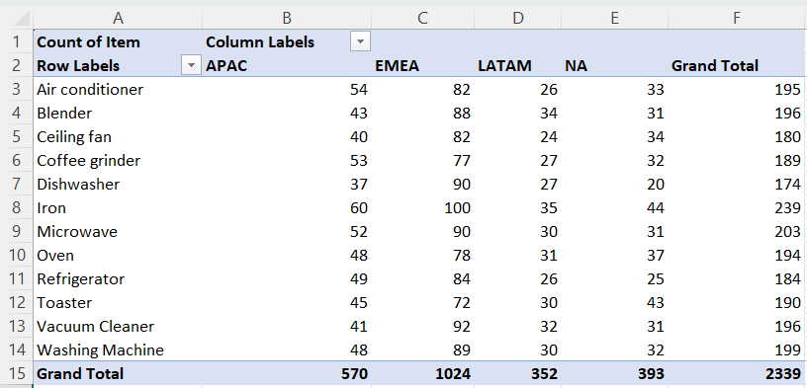 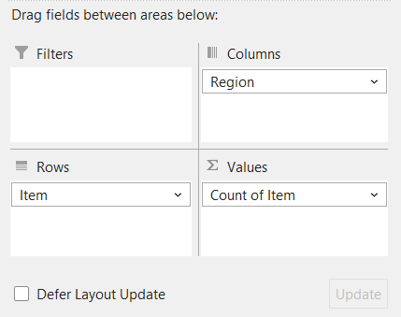

|  |  |  |  |  |  |  |
| --- | --- | --- | --- | --- | --- | --- |
| 4) Now, based on your last Pivot Table, Apply filter so only Microwave, Oven and Refrigerators will show in "Item". | | | | | | |
| Additionally, remove NA from the "Region" field.      5) Now, show the Average Discount % per Sales Person. Apply an external filter that will show only sales made in Columbia2. Sort the results in Ascending Order. Who's the best sales agent? |  |  |  | |  |  |
|  |  | | |  | | |  |  |  |

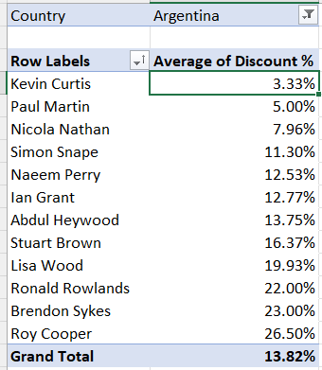 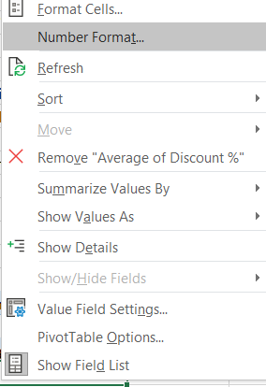 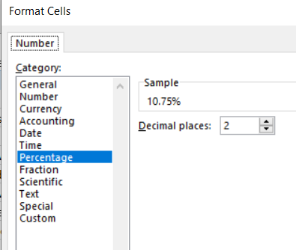

Let's dig deeper, by dragging Item (Count) and Actual Price (Sum) - To see how Gary performed quantity-wise:

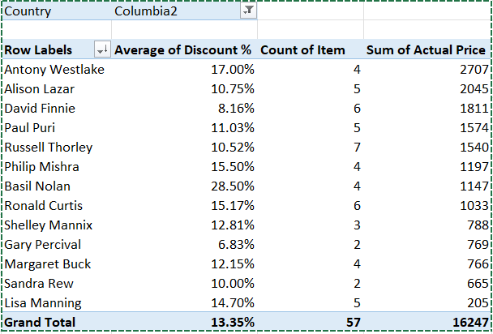 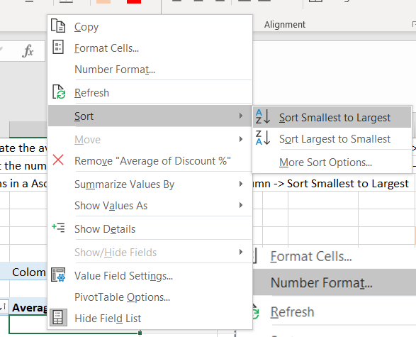

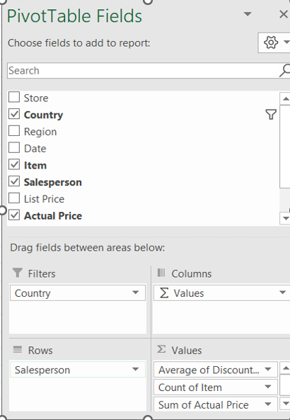

**Now, if we sort the Sum of Actual Price column from Largest to Smallest, we can see that Anthony Westlake sold 4 times more in $ than Gary!**

**Additionally, Many other sales agents sold more items than Gary. We could understand it quite easily using Pivot Table!**

6] Create a report detailing the $ Sales by Region, Country and Store, in the following format:

|  |  |  |  |  |
| --- | --- | --- | --- | --- |
| **Region** | **Country** | **Store** | **Sales** |  |
| EMEA | Russia | Moscow | 123 |  |
| APAC | Japan | Tokyo | 456 |  |

Answer :

To solve this, we can insert multiple fields into our Rows area, by dragging them one after the other.

We will start by dragging the Region, Country and Store fields to the Rows area:

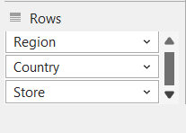

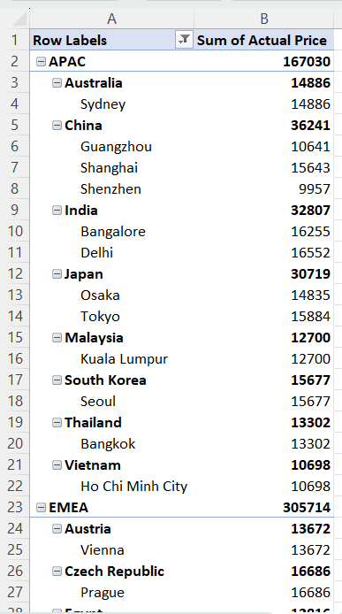 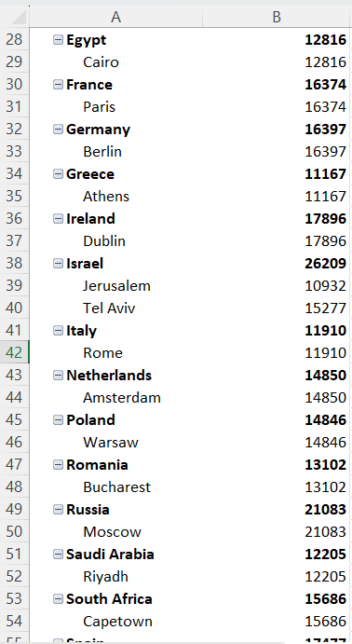 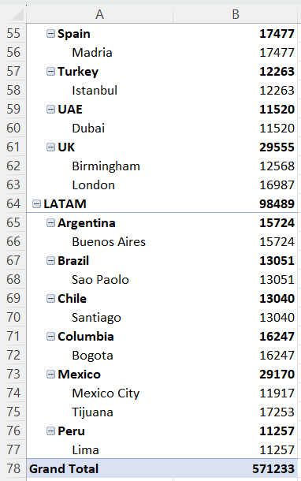

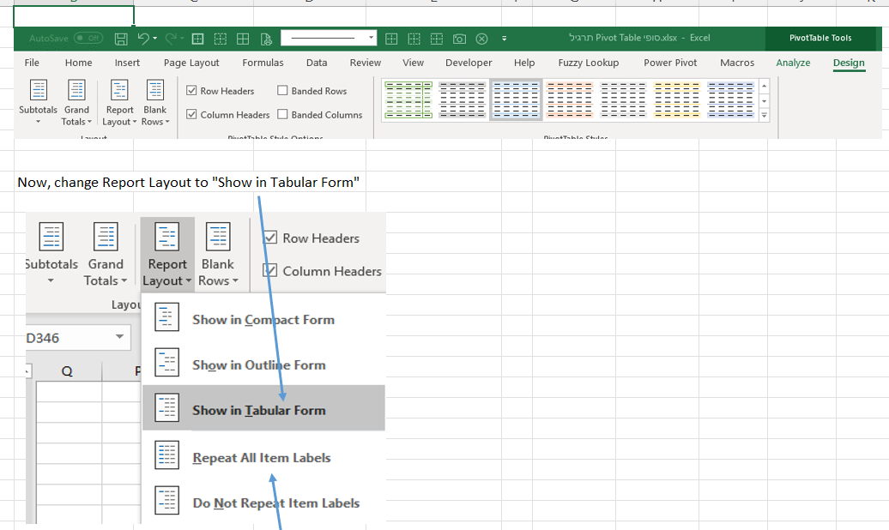

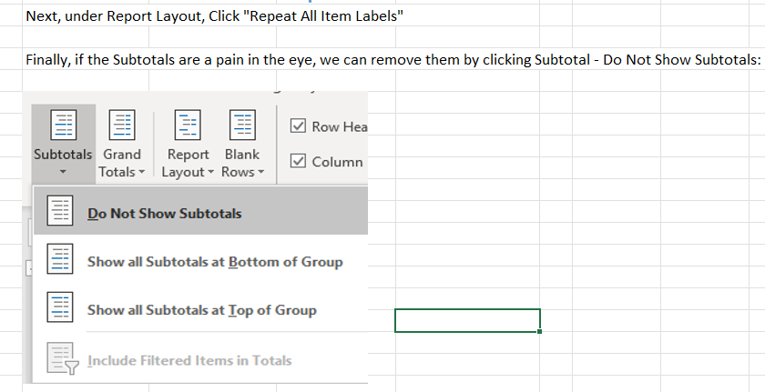

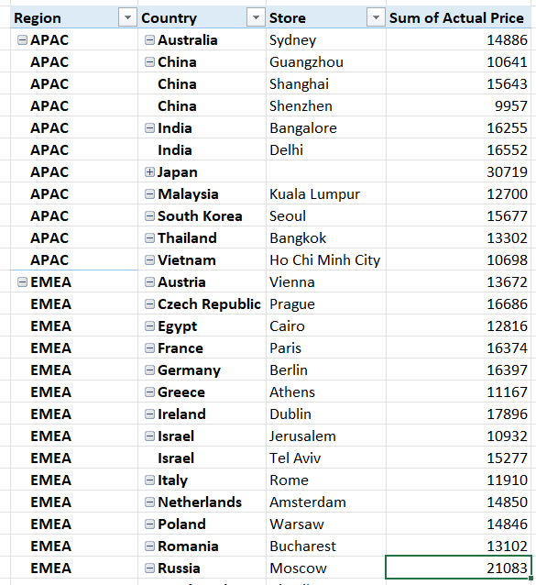 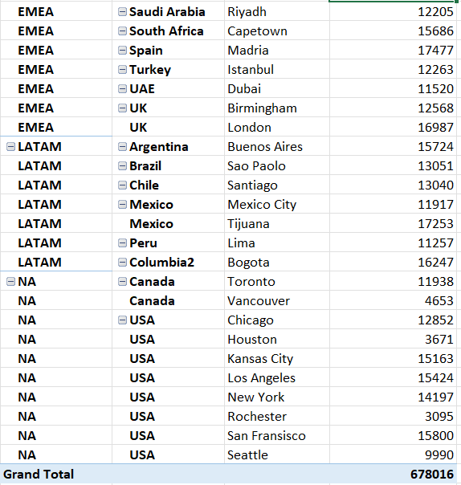

7) Based on the table from the previous question, and without removing any field - How can you change the pivot to group the values to be shown on a Region basis only? For Example:

Answer:

|  |  |
| --- | --- |
| EMEA | 123 |
| APAC | 456 |
|  |  |

For that, we can click on one of the cells under Region in the Pivot Table, then click Analyze, then click Collapse:

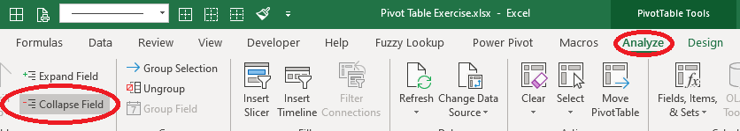

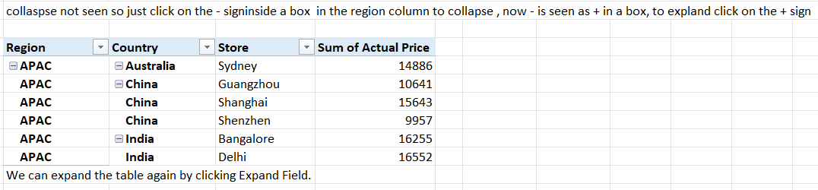

**Example 1**

**What is a pivot table?**

* You can think of a pivot table as a **report.**
* With very little effort (and no formulas) you can look at the *same data from many different perspectives*.
* You can **group data** into categories, break down data into years and months, filter data to include or exclude categories, and even build charts.

***The beauty of pivot tables is they allow you to interactively explore your data in different ways.***

**Sample data**

The sample data in Excel contains **452 records with 5 fields of information: Date, Colour, Units, Sales, and Region.**

**Insert Pivot Table**

1. To start off, select *any cell in the data* and click Pivot Table on the Insert tab of the ribbon:

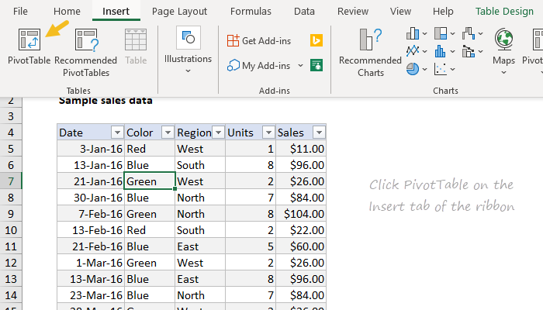

Excel will display the Create Pivot Table window. Notice the data range is already filled in. The default location for a new pivot table is New Worksheet.

2. Override the default location and enter H4 to place the pivot table on the current worksheet:

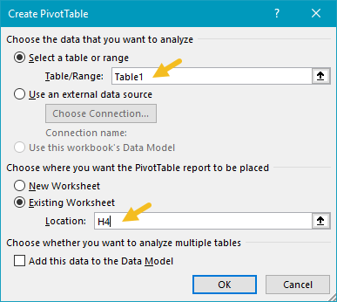

3. Click OK, and Excel builds an empty pivot table starting in cell H4.

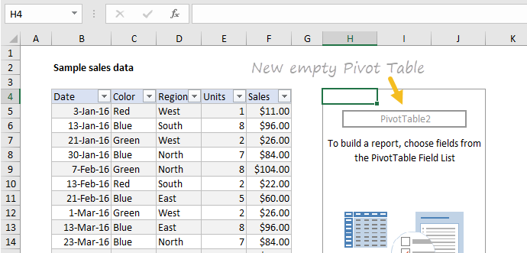

***Note: there are good reasons to place a pivot table on a different worksheet. However, when learning pivot tables, it's helpful to see both the source data and the pivot table at the same time.***

Excel also displays the PivotTable Fields pane, which is empty at this point. Note all five fields are listed, but unused:

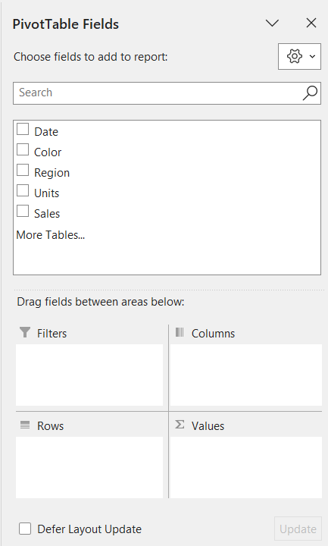

To build a pivot table, drag fields into the Columns, Rows, or Values area. The Filters area is used to apply global filters to a pivot table.

**Add fields**

1. Drag the Sales field to the Values area.

Excel calculates a grand total, 26356. This is the sum of all sales values in the entire data set

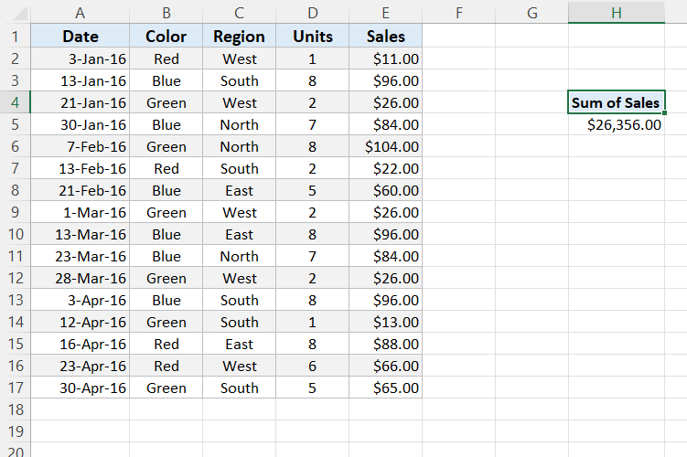

2. Drag the Color field to the Rows area.

Excel breaks out sales by Color. You can see Blue is the top seller, while Red comes in last:

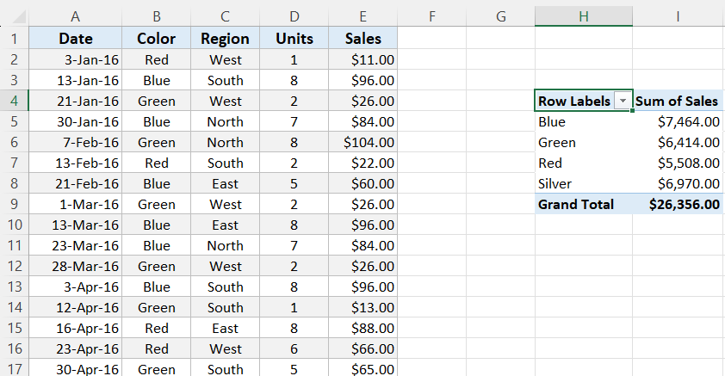

Notice the Grand Total remains 26356. This makes sense,because we are still reporting on the full set of data.

Let's take a look at the fields pane at this point. You can see Color is a Row field, and Sales is a Value field:

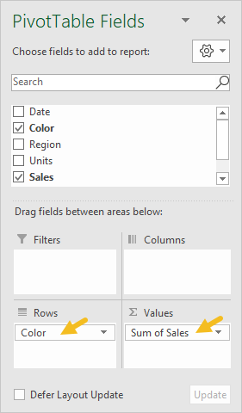

**Number formatting**

Pivot Tables can apply and maintain number formatting automatically to numeric fields. This is a big time-saver when data changes frequently.

1. Right-click any Sales number and choose Number Format:

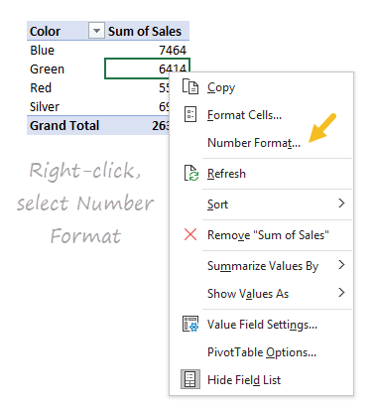

2. Apply Currency formatting with zero decimal places, the click OK:

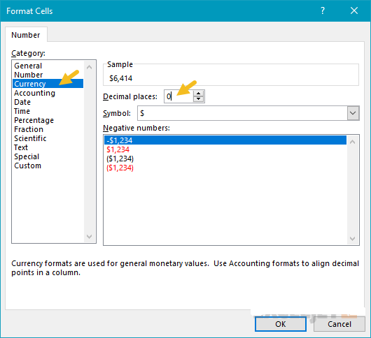

In the resulting pivot table, all sales values have Currency format applied:

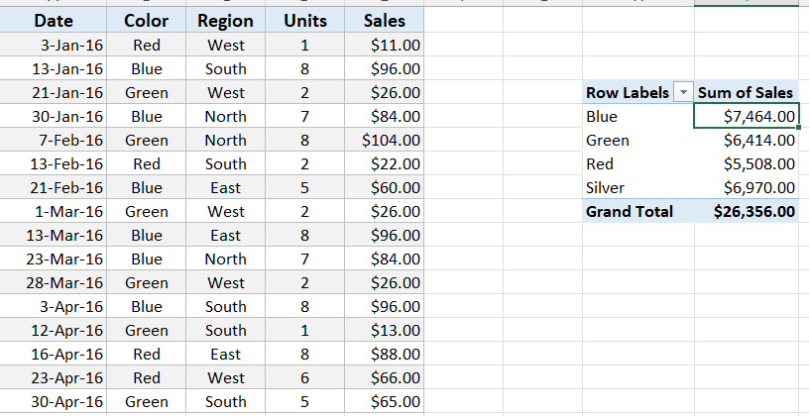

Currency format will continue to be applied to Sales values, even when the pivot table is reconfigured, or new data is added.

**Sorting by value**

1. Right-click any Sales value and choose Sort > Largest to Smallest.

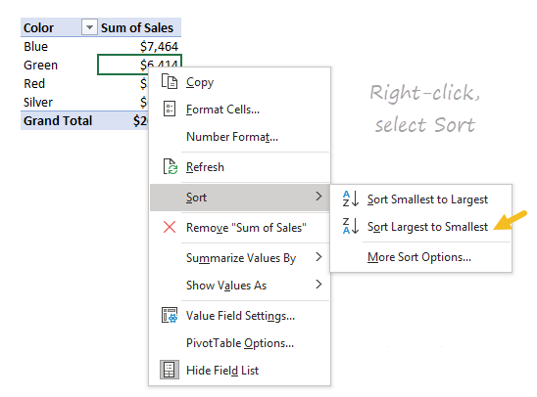

Excel now lists top-selling colors first. This sort order will be maintained when data changes, or when the pivot table is reconfigured.

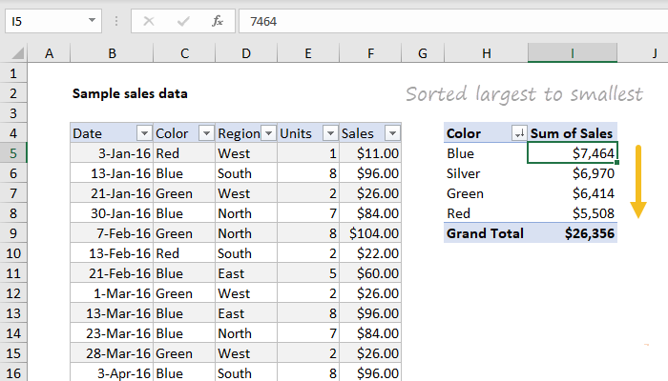

**Refresh data**

Pivot table data needs to be "refreshed" in order to bring in updates. To reinforce how this works, we'll make a big change to the source data and watch it flow into the pivot table.

1. Select cell F5 and change $11.00 to $2000.

2. Right-click anywhere in the pivot table and select "Refresh".

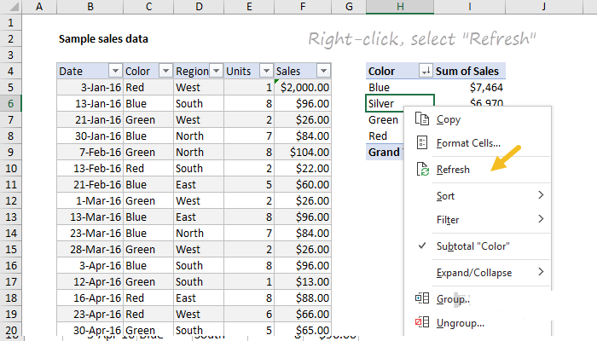

Notice "Red" is now the top selling color, and automatically moves to the top:

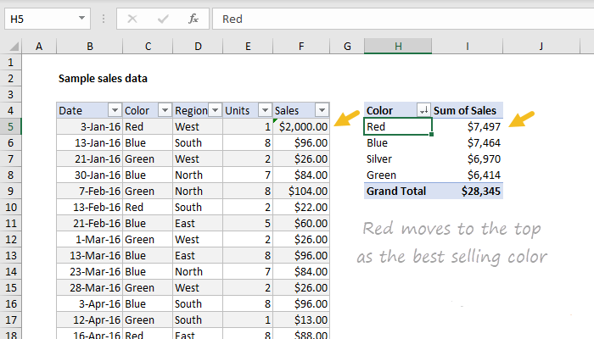

1. Change F5 back to $11.00 and refresh the pivot again.

**Second value field**

You can add more than one field as a Value field.

1. Drag Units to the Value area to see Sales and Units together:

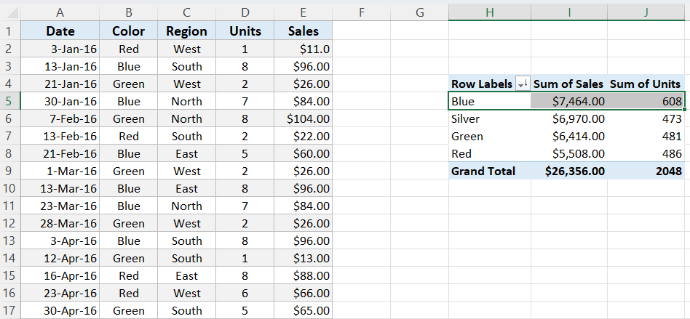

**Percent of total**

There are different ways to display values. One option is to show values as a percent of total. If you want to display the same field in different ways, add the field twice.

1. Remove the Units from the Values area

2. Add the Sales field (again) to the Values area.

3. Right-click the second instance and choose "% of grand total":

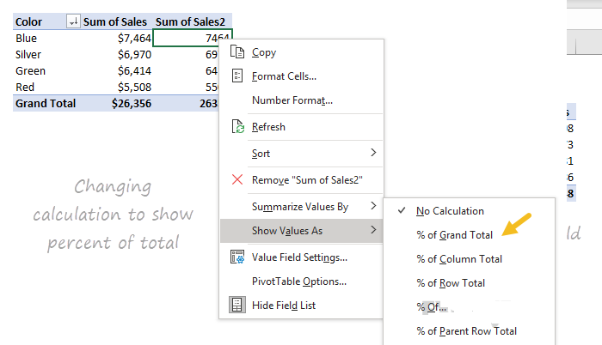

The result is a breakdown by color along with a percent of total:

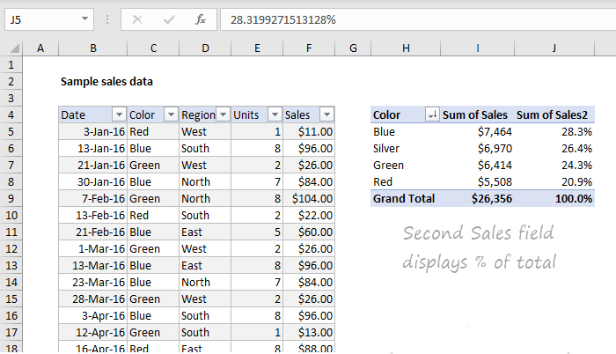

**Group by date**

Pivot tables have a special feature to group dates into units like years, months, and quarters. This grouping can be customized.

1. Remove the second Sales field (Sales2).

2. Drag the Date field to the Columns area.

3. Right-click a date in the header area and choose "Group":

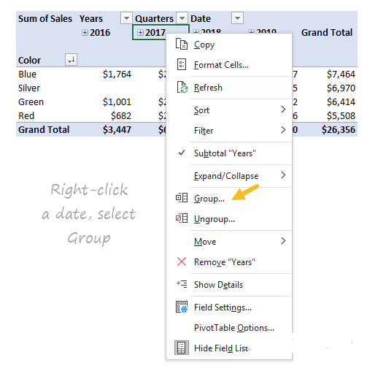

4.When the Group window appears, group by Years only (deselect Months and Quarters):

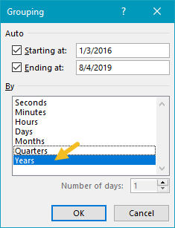

We now have a pivot table that groups sales by color and year:

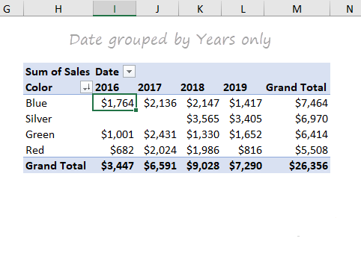

Notice there are no sales of Silver in 2016 and 2017.

**We can guess that Silver was introduced as a new color in 2018.**

Pivot tables often reveal patterns in data that are difficult to see otherwise.

Here is the Fields pane at this point:

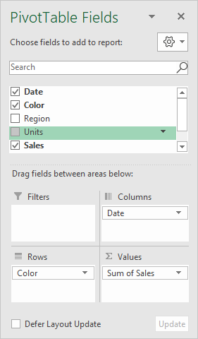

**Two-way Pivot**

Pivot tables can plot data in various two-dimensional arrangements.

1. Drag the Date field out of the columns area

2. Drag Region into the Columns area.

Excel builds a two-way pivot table that breaks down sales by color and region:

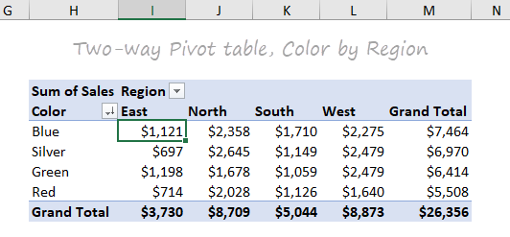

3. Swap Region and Color (i.e. drag Region to the Rows area and Color to the Columns area).

Excel builds another two-dimensional pivot table:

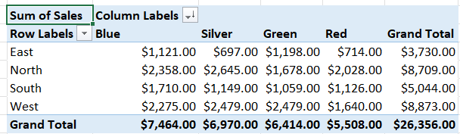

**Example 2**

Our data set consists of 213 records and 6 fields. Order ID, Product, Category, Amount, Date and Country.

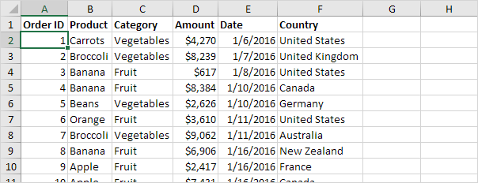

### Insert a Pivot Table

To insert a **pivot table**, execute the following steps.

1. Click any single cell inside the data set.

2. On the Insert tab, in the Tables group, click PivotTable.

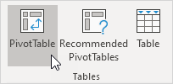

The following dialog box appears. Excel automatically selects the data for you. The default location for a new pivot table is New Worksheet.

3. Click OK.

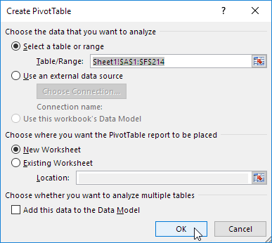

### Drag fields

The **PivotTable Fields pane** appears. To get the **total amount exported of each product**, drag the following fields to the different areas.

1. Product field to the Rows area.

2. Amount field to the Values area.

3. Country field to the Filters area.

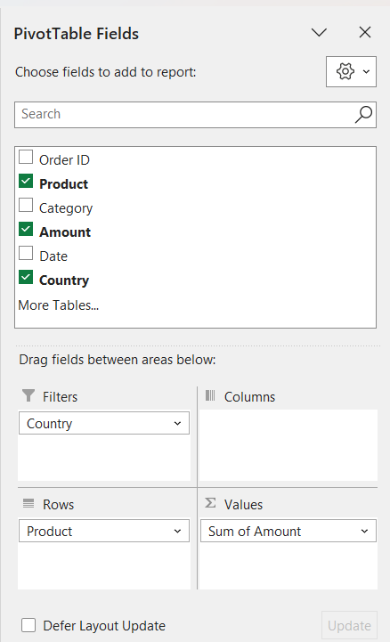

Below you can find the pivot table. Bananas are our main export product. That's how easy pivot tables can be!

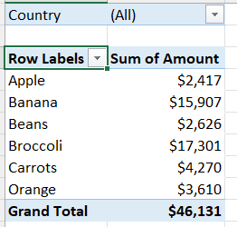

### Sort

To get Banana at the top of the list, sort the pivot table.

1. Click any cell inside the Sum of Amount column.

2. Right click and click on Sort, Sort Largest to Smallest.

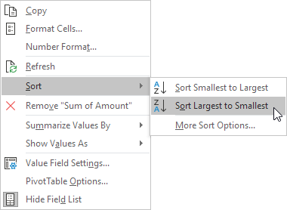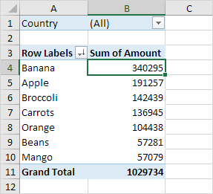

### Filter

Because we added the Country field to the Filters area, we can filter this pivot table by Country. For example, which products do we export the most to France?

1. Click the filter drop-down and select France.

Result. Apples are our main export product to France.

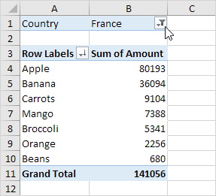

### Change Summary Calculation

By default, Excel summarizes your data by either summing or counting the items. To change the type of calculation that you want to use, execute the following steps.

1. Click any cell inside the Sum of Amount column.

2. Right click and click on Value Field Settings.

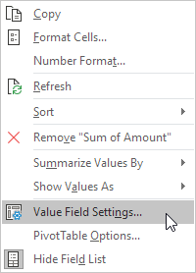

3. Choose the type of calculation you want to use. For example, click Count.

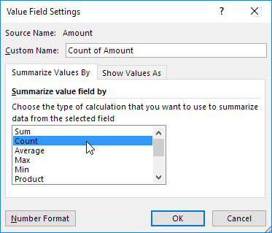

4. Click OK.

Result. 16 out of the 28 orders to France were 'Apple' orders.

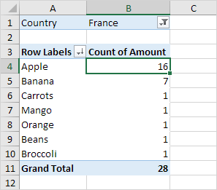

### Two-dimensional Pivot Table

If you drag a field to the Rows area and Columns area, you can create a two-dimensional pivot table. First, [insert a pivot table](https://www.excel-easy.com/data-analysis/pivot-tables.html#insert-pivot-table).

Next, to get the **total amount exported to each country, of each product**, drag the following fields to the different areas.

1. Country field to the Rows area.

2. Product field to the Columns area.

3. Amount field to the Values area.

4. Category field to the Filters area.

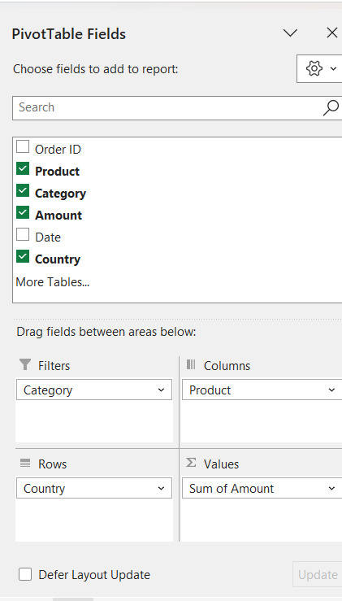

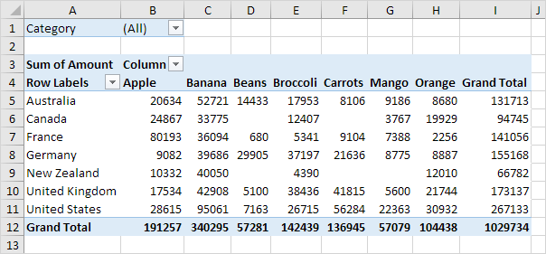

# Pivot Chart

A **pivot chart** is the visual representation of a pivot table in **Excel**. Pivot charts and pivot tables are connected with each other.

Below you can find a two-dimensional pivot table.



### Insert Pivot Chart

### If you don't see the Pivot Table Analyze tab when you click a Pivot Table, please click File > Options > Customize the Ribbon> Select **Tool Tabs** from the drop-down list of Customize the Ribbon box > Locate PivotTable Tools > Make sure Analyze (PivotTable Analyze) Tab is enabled.

To insert a pivot chart, execute the following steps.

1. Click any cell inside the pivot table.

2. On the Analyze tab, in the Tools group, click PivotChart.

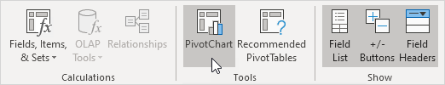

The Insert Chart dialog box appears.

3. Click OK.

Below you can find the pivot chart. This pivot chart will amaze and impress your boss.

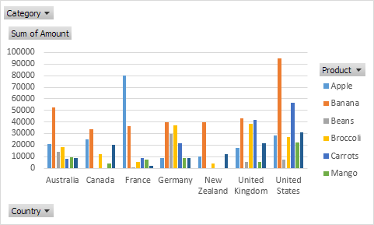

Note: any changes you make to the pivot chart are immediately reflected in the pivot table and vice versa.

### Filter Pivot Chart

To filter this pivot chart, execute the following steps.

1.Use the standard filters (triangles next to Product and Country). For example, use the Country filter to only show the total amount of each product exported to the United States.

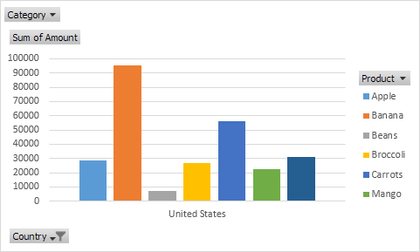

2. Remove the Country filter.

3. Because we added the Category field to the Filters area, we can filter this pivot chart (and pivot table) by Category. For example, use the Category filter to only show the vegetables exported to each country.

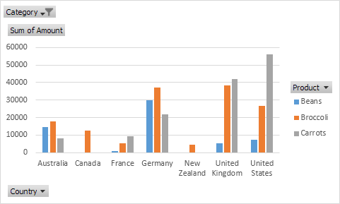

### Change Pivot Chart Type

You can change to a different type of pivot chart at any time.

1. Select the chart.

2. On the Design tab, in the Type group, click Change Chart Type.

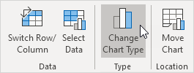

2.Choose Pie

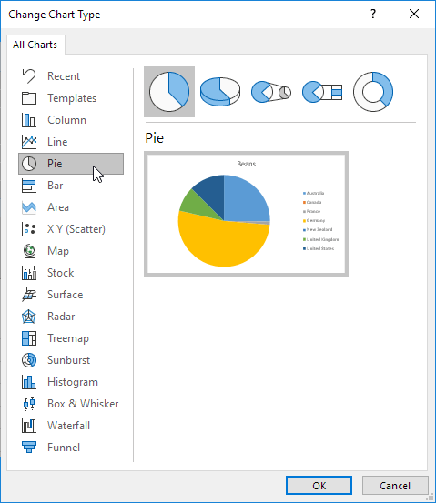

4. Click OK.

**Result:**

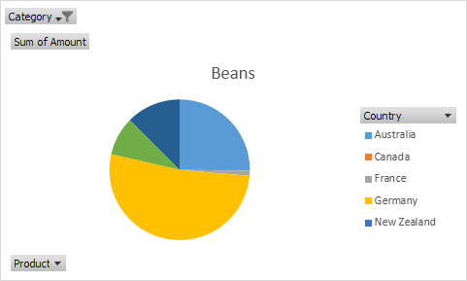

**Note: pie charts always use one data series (in this case, Beans).**

To get a pivot chart of a country, swap the data over the axis. First, select the chart. Next, on the Design tab, in the Data group, click Switch Row/Column.